| **REV.** | | **Description** | | | | | | **Date** | |
| --- | --- | --- | --- | --- | --- | --- | --- | --- | --- |
| 00 | |  | | | | | |  | |
|  | |  | | | | | |  | |
|  | |  | | | | | |  | |
|  | |  | | | | | |  | |
|  | |  | | | | | |  | |
|  | |  | | | | | |  | |
|  | |  | | | | | |  | |
|  | |  | | | | | |  | |
|  | |  | | | | | |  | |
|  | |  | | | | | |  | |
|  | |  | | | | | |  | |
|  | |  | | | | | |  | |
|  | |  | | | | | |  | |
|  |  | | | **台達電子工業股份有限公司**  **DELTA ELECTRONICS, INC.** | | | DESCRIPTION :  **電氣規格(Electrical Specification)** | | |
|  | **THESE DRAWINGS AND SPECIFICATIONS ARE THE PROPERTY OF DELTA**  **ELECTRONICS, INC. AND SHALL NOT BE REPRODUCED OR USED AS THE**  **BASIS FOR THE MANUFACTURE OR SELL OF APPARATUSES OR DEVICES**  **WITHOUT PERMISSION.** | | | | | | MODEL NO. :  **ADP-65JW X2X SERIES** | | |
|  | Date | | Drawn | | Design (EE) | Design (ME) | DOCUMENT NAME. :  **ES-65JW X2X SERIES** | | REV. |
|  | 05/15’24 | | 王玉玲 | | 陳俊宇 | 陳俊豪/張伯毅 | 06 |

FRAME NAME:DF-PSLA4V-2R01.DOC SHEET 1 OF 18

MODEL LIST

|  |  |
| --- | --- |
| MODEL NAME | TYPE |
| ADP-65JW Y2A/Y2B/ Y2C/Y2D | US |
| ADP-65JW X2A | CN |
| ADP-65JW Z2A/ Z2C | EU |

1. ELECTRICAL
   1. Input Characteristics:
      1. Nominal Voltage

It is normal for **100 ~ 240Vac** input AC voltage.

* + 1. Input Voltage Range

The Adapter shall operate from **90 ~ 264Vac**.

* + 1. Rated Frequency

It is normal for **50Hz** or **60Hz** and single phase.

* + 1. Frequency Range

The Adapter shall operate with an input frequency from **47 Hz** to **63 Hz**.

* + 1. Input Current

**1.5A** Max at **100Vac** input voltage.

* + 1. Inrush Current Limit (cold start)

The I2t shall less then 22% of the Fuse.

* + 1. Efficiency (Warm Up)
       1. Nominal input voltage, maximum load and measured at the end of DC cable.

(Warm up after 30min )

|  |  |
| --- | --- |
| Vout | Efficiency |
| 5 | 79.3% |
| 9 | 84.5% |
| 15 | 86.5% |
| 20 | 87.0% |

* + - 1. Active mode efficiency:

average efficiency of **25%,50%,75%** and **100%** load tested at **115Vac/60Hz** and **230Vac/50Hz**.(Warm up after 30min)

|  |  |
| --- | --- |
| Vout | Efficiency |
| 5 | 81.84% |
| 9 | 87.30% |
| 15 | 88.85% |
| 20 | 89.00% |

The efficiency at 10% loading shall be more than 72.48% (5V) ; 77.3%(9V) ; 78.86%(15V) 79.00%(20V) measure at 115Vac/60Hz and 230Vac/50Hz

* + 1. No Load Power Consumption

5V only: Maximum non-load power consumption is less than **0.15**W at **115Vac/60Hz** and **230Vac/50Hz**

* + 1. Power saving requirement

115Vac/60Hz , 230Vac/50Hz. (20V)

|  |  |
| --- | --- |
| DC POWER(W) | AC Spec. Power ( W ) |
| 18.0 | <21 |
| 11.0 | <14 |
| 5~6.5 | Eff.>80% |
| 3 | <5 |
| 1.65 | <3 |
| 1.5 | <2.2 |
| 1 | <1.6 |
| 0.25 | <0.48 |

* 1. Output Characteristics:
     1. Rated Voltage

The rated output voltage is specified at **5V / 9V / 15 / 20V**.

* + 1. Voltage Range

The output voltage range

|  |  |
| --- | --- |
| Vout | Voltage Range |
| 5 | 4.85~5.5V |
| 9 | 8.55~9.45V |
| 15 | 14.25~15.75V |
| 20 | 19~21V |

* + 1. Current

This Adapter can work from **0** **A** to **3 A (5V~15V)** and **0** **A** to **3.25 A (20V)** output voltage is in section 1.2.2 specified range.

|  |  |
| --- | --- |
| Vout | Load |
| 5 | 0~3A |
| 9 | 0~3A |
| 15 | 0~3A |
| 20 | 0~3.25A |

* + 1. Output Ripple and Noise

Output ripple voltage is **180mV / 200mV / 300mV / 300mV** peak to peak.

Measured methods:

T1. Performed by **20M** Hz bandwidth in oscilloscope.

T2. Applied **0.1uF** high frequency capacitor and **10uF** electrolytic capacitor across output connector terminals.

T3. Measured at the end of DC cable.

T4. 47Hz and 63Hz tested at 90Vac and 264Vac. @ 25℃

|  |  |
| --- | --- |
| Vout | Ripple and Noise |
| 5 | 180mV |
| 9 | 200mV |
| 15 | 300mV |
| 20 | 300mV |

* + 1. Turn On delay time

The Adapter shall switch on in less than **3 seconds** (5V only) at input voltage is 100Vac~240Vac.

* + 1. Hold –up time

The output voltage shall be sustained **5mS** (20V only) within regulation requirement after loss 100Vac and maximum load.

* + 1. Rise time

DC output rise time from 10% to 90% of output voltage shall be less than **40mS** (5V only) at nominal line and maximum load.

* + 1. Overshoot

The output overshoot at turn on shall not exceed **10%** of normal voltage value with or without the load connected.

* + 1. Peak load (20V/15V only)

The adapter shall support below loading condition without and damage, safety issues and protection happen. The output voltage shall more than **17.8V(20V mode) / 13V(15V mode)** at input voltage is **100-240Vac/50Hz** in 25℃.

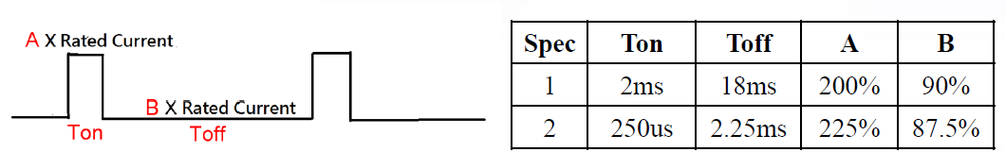

* + 1. Surge load (20V/15V only)

The adapter shall support a surge load with 120%of maximum load for 1min **,** maximum load for 9minand Output Voltage more than **18.5V /13.7V** at input voltage is 100-240Vac in 25℃.

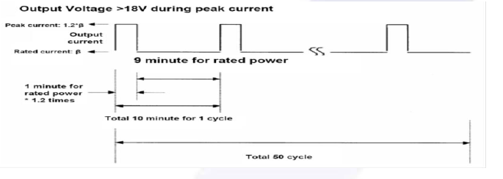

* + 1. Load transient response

(1) For 5V Output and 9V output must to meet condition 1 and condition 2

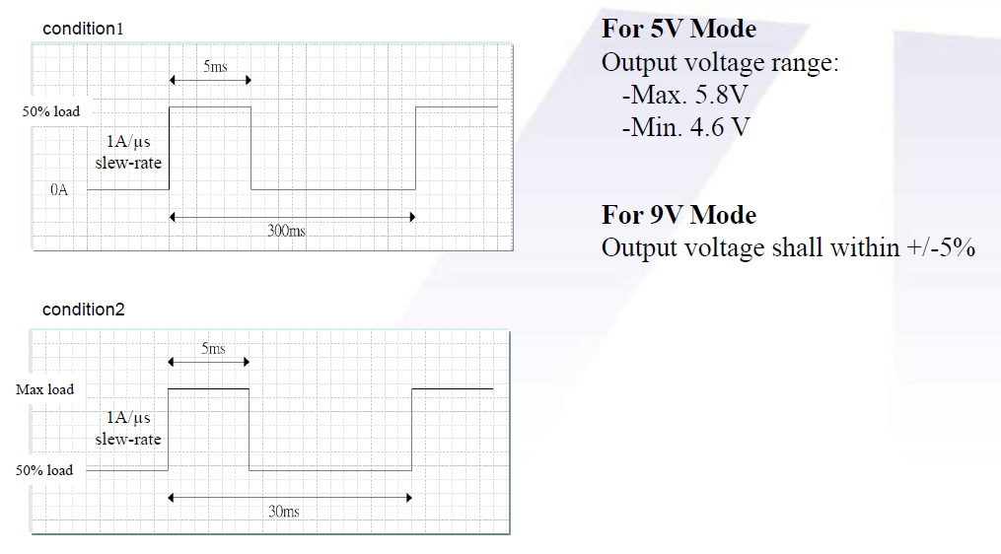

(2) The adapter must within regulation when applied a step load from 0.05A to 100% load at

2.5A/us slew rate , 50% Duty cycle , Frequency be operated 100Hz/100KHz in 25℃.

The output voltage will be performed **14.25~15.75(15V); 19 ~ 21V(20V)**

* + 1. Protection
       1. Over Voltage Protection

The output shall be protected to **AC latch-off** at over-voltage condition**.** That might be return to normal state by AC reset.

|  |  |
| --- | --- |
| Vout | OVP |
| 5 | 7.5V |
| 9 | 13.5V |
| 15 | 20.25V |
| 20 | 27V |

* + - 1. Over Current Protection

The adaptor shall be **DC latch-off**. (It will enter into normal condition by re-plug in DC plug)

|  |  |
| --- | --- |
| Vout | OCP |
| 5 | 3.6A max |
| 9 | 3.6A max |
| 15 | 3.9A~5A max |
| 20 | 3.9A~5A max |

* + - 1. Short Circuit protection

Output can be shorted without damage. The adaptor shall be **DC latch-off**. (It will enter into normal condition by re-plug in DC plug)

* + - 1. Over Temperature Protection

No deformation and no discoloration on case and will be shut down (**AC or DC latch-off**). That will be return to normal state by re-plug in DC plug.

1. Environmental
   1. Temperature

2.1.1 Operating

The AC Adapter shall be capable of operating at full load with an ambient temperature range of **0 ℃**

**to +40℃**.

2.1.2 Shipping/Storage

The AC Adapter shall be capable of withstanding ambient temperature from **-30℃ to +80℃**.

2.2 Humidity

2.2.1 Operating

The AC Adapter shall be capable of operation in relative humidity of **5% to 90%** relative humidity,

non-condensing.

2.2.2 Shipping/storage

The AC Adapter shall be capable of withstanding ambient relative humidity of **5% to 95%** relative

humidity, non-condensing.

2.3 Immunity

2.3.1 Lightning Surge Immunity

This is to follow the norm of IEC-1000-4-5 Level 3 requirements.

L-N +-1KV/1.2 * 50uS 5 times No function error.

L-FG, N-FG +-2KV/1.2 * 50uS 5 times No function error.

2.3.2 Electric Fast Transients(EFT)

This is to follow the norm of IEC-1000-4-4/1995

(EN 61000-4-4) Level 3 requirements

2.4 Electrostatic Discharge (ESD)

This Adapter is capable to withstand ESD test voltage at any point around the enclosure as below.

±15KV air discharge performance criterion B.

±12KV air discharge performance criterion A.

±8KV contact discharge performance criterion A.

2.5 Surface Temperature rise

Ambient **40℃**; input voltage 100Vac/240Vac case temperature rise≦**40℃** with system loading (95%) on

bakelite.

2.6 Dielectric Withstand Voltage (HI – POT)

Between AC input and secondary AC 3KV test time 1 minute; 100% of line products of this Adapter shall be applied 3000Vac for 2 seconds between AC input terminals and output terminals. Cut off current 10mA.

* 1. Leakage Current

Y cap no more than 220pF.

Leakage current no more than 20uA(max) at 240Vac/50Hz.for delta product line.

* 1. Insulation Resistance

The insulation resistance shall be not less than **30M** ohms after application of **500Vdc/10mA for 1 minute**.

* 1. Electromagnetic Interference (EMI)

The adapter shall comply with the following national standards.

1. FCC Part 15.
2. CISPR 22 Class B.
3. The limits shall be meet with a margin more than 4dB with all system applicable.
   1. MTBF
      1. MTBF (Mean-Time-Between-Failures) Calculation

The calculated MTBF shall be **150,000** hours of continuous operation at **25℃**,

maximum load and 100Vac / 240Vac.

* + 1. Electrolytic aluminum cap. Lifetime

The lifetime is least 13140 hours in Full load at 25**℃**at 100Vac/60Hz and 240Vac/50Hz.

* 1. Safety request

Meet IEC 60950-1

Meet IEC 62368-1

Meet LPS

Meet DOE Level6

Meet COC Tire2

* 1. Acoustic test

**Input Condition**

Vin: 90Vac~264Vac Frequency : 47Hz to 63 Hz  
**Load Condition:**  
(a)Dynamic  Load follower ASUS  Spec   
(b)Static  Load  (from 0A to Full Load , 0.1A pre step )

NB ADAPTER SPEC :

**Static Load**

WM Type : Microphone at a distance of 10cm from the surface and noise level is less than 20dB

Desktop Type : Microphone at a distance of 5cm from the surface and noise level is less than 20dB  
**Dynamic Load**

WM Type : Microphone at a distance of 10cm from the surface and noise level is less than 25dB

Desktop Type : Microphone at a distance of 5cm from the surface and noise level is less than 25dB

1. Mechanical
   1. Outline Dimension: 63.0 * 63.0 * 28.5 mm, color: Black
   2. Plug Type

|  |  |
| --- | --- |
| **MODEL LIST** | **Type** |
| ADP-65JW Y2A/Y2B/Y2C/Y2D | US |
| ADP-65JW X2A | CN |
| ADP-65JW Z2A/Z2C | EU |

* 1. DC Cable Length: 2000 mm
  2. DC Cable Type: UL20276 18AWG*2+24AWG*1
  3. DC Connector Dimension: USB TYPE C
  4. Pin assignment of Type C connector:  
     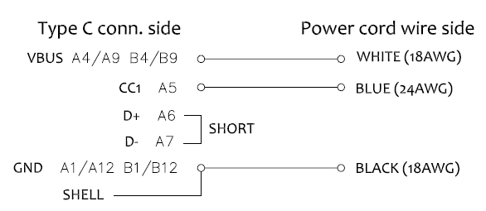
  5. Adapter Weight:

|  |  |
| --- | --- |
| **MODEL LIST** | **Weight** |
| ADP-65JW Y2A/Y2B/ Y2C/Y2D | 210 g ± 2.5% |
| ADP-65JW X2A | 210 g ± 2.5% |
| ADP-65JW Z2A/ Z2C | 223 g ± 2.5% |

**Mechanical characteristics**

|  |  |  |  |
| --- | --- | --- | --- |
|  | Item | Conditions | Specification |
| 1. | Cord flexibility test(Delta spec) | Hang the specified weight and swing it to one direction and return to the original position then swing to the opposite direction and return to the original position. This constitutes one cycle. The DC power supply shall be subjected to the specified cycles a specified speed.   1. Weight: 200g 2. Swing angle (θ): 0 ~ 180° 3. Cycles: 1000,3000,10000cycles 4. Speed: 40 cycles/min. 5. Compliance: case SR, Plug SR | Disconnection rate of the wire shall be  1000 cycles –less 10%  for Plug SR  3000 cycles – less 20%  for case SR  3000 cycles – less 30%  10000 cycles – less 100% without damage to the insulations, etc.. |
| 2. | Cord flexibility test (Customer Spec.) | Hang the specified weight and swing it to one direction and return to the original position then swing to the opposite direction and return to the original position. This constitutes one cycle. The DC power supply shall be subjected to the specified cycles a specified speed.  (If the cable is without core don’t need core SR test )    1. Weight: 200g  2.Swing angle (θ): +/- 90°  3.Cycles: 3000 cycles  4.Speed: 40 cycles/min.  5.Compliance:  plug SR, case SR. | Disconnection rate of the wire shall be 30% or less for plug SR, core SR and 10% or less for case SR, without damage to the insulations, etc.. |
| 3. | Cord tensile test | A static load shall be applied and sustained for a period. Excessive load shall not be applied in this test, unless special request.  Load (w): 10 kgf  Durance: 60 sec | Contact part and bushing shall not be detached. |
| 4. | Vibration | Non-operating, Random vibration:  5~100 Hz 0.015 G2/Hz  100~137 Hz 6 dB/oct  137~350 Hz 0.008 G2/Hz  350~500 Hz -6 dB/oct  Acceleration: 2.09 Grms  Duration: 20 min.  Direction: X,Y,Z | 1. PSU must operate with specification after non-operation test.  2. PSU shall be no mechanical damage after test. |
| 5. | Shock | Non-operating  1. Pulse: Half sine wave.  2. Peak acceleration: 50 G  3. Duration: 11 ms  4. Number of shock: 1 shock per each direction, 6 directions. | 1. PSU must operate with specification after non-operation test.  2. PSU shall be no mechanical damage after test. |

|  |  |  |  |
| --- | --- | --- | --- |
|  | Item | Conditions | Specification |
| 6. | Drop test  (with outline label) | 1. Operating  a. The drop height: H= 76 cm.  b. The drop orientation: 6 face for each.  c. Power on | 1. ATS function Pass.  2. No PWB copper pad peeling and broken.  3. No soldering crack. 　 　　 4. No component broken..  5. Hi-pot test pass with specific condition. 　　6. Test Finger can’t touch the Hazardous Voltage of the product. |
| 2. Non-operating  a. Drop height: H= 110 cm.  b. The drop orientation: 6 face for each. |
| 3. Low height drop  Drop TIMES: 130 times for every surface (six side), 780 times in total.  Test surface material : The concrete  Drop height: 10cm |
| 4. Equipment: |  |

|  |  |  |  |
| --- | --- | --- | --- |
|  | Item | Conditions | Specification |
| 7. | Ball impact  (with outline label) | 1. Steel ball: 0.54 kgf .  2. Drop height: 30 cm.  3. A horizontal surface of laminated wood of hardwood at least 13mm  thick, mounted on two layers of plywood each 19mm to 20mm thick,  all supported on a concrete floor.  4. Impact location: Classify according to DUT’s dimension. LxWxH    L+W <150 B,D,F,H,I,K  150<L+W <200 A,C,D,E,G,H,I,J,K,L  200<L+W A,B,C,D,E,F,G,H,I,J,K,L    5. Equipment: | 1. Hi-pot test pass with specific condition.  2. Test Finger can’t touch the Hazardous Voltage of the product. |
| 8. | AC Inlet Bending(I) | 1. Bending angle 15 °for either side.  2. Bending speed 10 times per minute.  3. Must withstand 30 times totally.  Equipment:  Arm controller: Delta. | 1. The blade can’t be any crack or damage.  2. This test refers to JIS C8303 requirement. |
| 9 | AC Inlet Bending(II) | 1. Bending angle 30 °for either side.  2. Bending speed 10 times per minute.  3. Must withstand 5 times totally.  Equipment:  Arm controller: Delta. | 1. The blade can’t be any crack or damage.  2. This test refers to JIS C8303 requirement. |
| 10 | Push Force | Push one side blade to touch another side. The force must over 4.08kgf.  Equipment:  Push-Pull force measurement controller ( 50kgf ) | No electrical or mechanical problem happened and no abnormity found in the shape. |
| 11 | Load Weight | A static load 351b (15.9kg) / 2min for both pin to downside.  Equipment:  Load weight controller: Delta. | No electrical or mechanical problem happened and no abnormity found in the shape. |
| 12 | Push Blade | Push both pin to inside that must withstand 20kgf / 1 min.  Equipment:  Push-pull force measurement controller ( 50kgf ) | No electrical or mechanical problem happened and no abnormity found in the shape |
| 13 | Side Thrust | External enclosures are subjected to a steady force 250N±10N for a period of 5 sec.  Sample: 2pcs  Test point: feature of product end.  Equipment:  Push-Pull force measurement controller (0 ~ 50kgf). | At worst case condition, there are no damage on plastic case and socket and MUST keep the minimum safety distance 5.0mm |
| 14 | Packing Test | Drop Test: Drop height is 350mm, testing method refers to 10000-0089  Vibration Test: Testing method refers to 10000-0089 | After test, the product should be no abnormal function and broken appearances. |

Product Applications: Notebook (ADP-65JW Y2A/X2A/Z2A/Y2C/Y2B/Y2C/Y2D/Z2C)

Product Ingress protection(IP) rating: Not requirement